|  |  |
| --- | --- |
| NUIM_logo (Hi-Quality) | **National University of Ireland, Maynooth** Department of Electronic Engineering  EE204: Analog Electronics |

## Title: The CMOS Inverter

## Number: 2

**EQUIPMENT**

Power supplies

Voltmeter/Ammeter

2 MOSFETs (N and P), 2 LEDs, 2 1k resistors, 1uF capacitor.

Breadboard

Three co-ax connectors

**OBJECTIVE**

The purpose of this experiment is to construct a logic inverter with a PMOS and an NMOS. Such a use of P and N MOSFET is often called CMOS technology (Complementary MOS) , because we are using N’s and P’s. In this experiment the behaviour and non-idealities of the inverter will be investigated.

### INTRODUCTION

The introduction will be skipped in this experiment as most of the experiment is based upon answering questions about the behaviour of the inverter.

### PROCEDURE

NOTE: LEDS are wrong way in the

Circuit, should be pointing to ground.

Construct the following circuit.



S

The transistor pin out for both devices is as follows

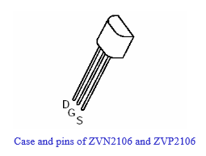

**The signal generator will be providing the input signal.**

The following images should give you an indication of how to wire up the breadboard.

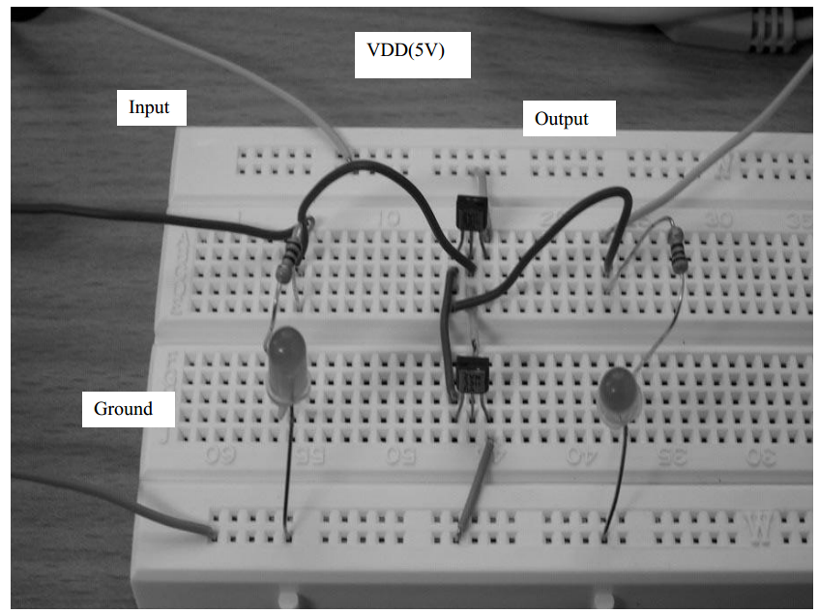

Using the oscilloscope, place probes so as to measure the input signal to and the output signal from the inverter. Check to make sure that the input signal is a square wave with an amplitude that is no greater than 5V. Check that there is no offset, ie the signal ranges from 0V to 5V. The signal frequency should be less than 10 Hertz, ie pick the 10Hz button on the frequency range. Use the control knob to reduce it further if necessary.

In this circuit the resistors and LED’s are only present to give an indication of the signal values, the inverter itself consists of only the two transistors.

If the circuit has been wired up correctly, the two LEDs will begin to flash in opposition to each other once power has been applied. Using the oscilloscope you should be able to confirm that there are two square waves, 180 degrees out of phase. Draw the waveforms that you see. Q: Are they perfectly square?

Centre on one edge of the square wave, say a rising edge of an input. Change the time setting on the oscilloscope to zoom in to the edge. You may need to move the edge with the horizontal shift control to keep it centered. With the increased resolution, and keep going until you see something, sketch and describe what you see and comment on how you believe may affect the performance of a digital circuit. Comment on how you believe such a behaviour may arise in a circuit.

Zoom in on the time axis even further, is there any delay between the input signal changing and the output signal changing. Q : What is this delay and at what input voltage does the output signal begin to change? Suggest a reason why this may be the case.

Modify the circuit and place a capacitor (1uF) between the two drains of the transistors and the ground. Remove the LED (D1) and 1K resistor. Comment on what effect increasing the capacitance at this node has on performance. Sketch the resulting waveform. Comment on how this could affect high frequency operation of an inverter. Note 1uF is a massive capacitance to place on a node and is unlikely to be present in an real application.

### REQUIRED RESULTS IN REPORT

To be uploaded via moodle before the next laboratory

Please transcribe the results of the questions in the order of experiment

Your report should have the following structure

* A brief introduction showing you know what the lab is about (3-4 lines MAX)
* For each section you need the following
  + - A drawing of the circuits used
    - Your results
    - Comments and Questions all answered.

Late reports can be emailed to me but will incur penalties of 10% per day (or part of a day, weekends are counted the same as weekdays).

|  |
| --- |
| **Marks will be deducted for poorly presentation, poorly written reports.**  **Marks will only be awarded for sections completed.** |